Versions:

Date | Versiune | Autor | Comentarii
07.12.2023 | V1 | Gelu-Samuel and Cot Catalin

Analisys&Design for <FootwearRedux >

Continut:
- General Presentation

- Theoretical Fundamentals

- IT Technology

- Functionalities

- Actors and related access rights

- Use Case Diagrams

- System Architecture

- Design (UML Diagrams)

- Operation Mode (Operation Guide, including screen-shots)

- Portability

1. General Presentation

FootwearRedux is an innovative e-commerce project developed using a technology stack that includes Java Spring Boot, React, and PostgreSQL it addresses two important aspects: sustainability and affordability in the footwear industry. It serves as a dedicated online marketplace for the buying and selling of pre-owned shoes. By focusing on the resale of second-hand footwear, the platform promotes a more sustainable approach to fashion and encourages responsible consumerism.
One of the core objectives of FootwearRedux is to tackle the issue of waste generated by the fashion industry. By creating a marketplace exclusively for pre-owned shoes, the platform aims to extend the lifecycle of footwear and reduce the overall environmental impact. Instead of discarding shoes that are still in good condition, users can list them on FootwearRedux, allowing others to discover and purchase these pre-loved items. This sustainable approach helps to minimize the environmental footprint associated with the production and disposal of shoes.
In addition to sustainability, FootwearRedux also aims to provide an affordable alternative for individuals looking to buy quality shoes. By facilitating the resale of second-hand footwear, the platform offers an opportunity for users to find unique and well-maintained shoes at lower prices. This affordability factor makes FootwearRedux an attractive option for budget-conscious consumers who still want to enjoy stylish and high-quality footwear without breaking the bank.
Moreover, FootwearRedux prioritizes user experience by creating a secure and user-friendly online marketplace. The platform ensures that users can confidently buy and sell shoes without concerns about fraudulent activities or unreliable sellers. With proper verification processes and secure payment options, FootwearRedux provides a trustworthy environment for all transactions. The platform's user-friendly interface and intuitive features make it easy for both buyers and sellers to navigate the marketplace, browse listings, and complete transactions seamlessly.
By combining sustainability, affordability, and a seamless user experience, FootwearRedux stands out as a unique and valuable product in the e-commerce space. It not only addresses the growing demand for sustainable fashion but also caters to consumers looking for cost-effective alternatives. With its focus on promoting responsible consumerism and providing a reliable platform for buying and selling pre-owned shoes, FootwearRedux contributes to a more sustainable and accessible footwear industry.

- Theoretical Fundamentals
Sustainability and Affordability :
FootwearRedux addresses the growing concern for sustainability in the fashion industry by providing an eco-friendly alternative for footwear enthusiasts. We recognize that high-quality footwear often comes at a significant financial and environmental cost. Our platform aims to mitigate these concerns by creating a marketplace that encourages the buying and selling of gently used shoes.
Mission Statement:
Our mission is clear: to establish a secure and user-friendly online marketplace where individuals can effortlessly buy and sell pre-owned shoes. We believe in the power of community and the importance of extending the lifecycle of footwear. By offering a platform for the exchange of second-hand shoes, we aim to reduce waste and make quality footwear accessible to a broader audience.
Safety and Transparency:
One of our primary focuses is ensuring a safe and transparent experience for all users of FootwearRedux. We have implemented stringent security measures and user-friendly features to facilitate secure transactions. Our platform's intuitive design simplifies the processes of listing, searching, and purchasing pre-owned shoes.
In conclusion, FootwearRedux is more than just an e-commerce platform; it is a testament to the potential of technology to drive positive change in society. This documentation will provide you with an in-depth understanding of our project, from its technological foundation to its sustainability goals and user-centric design. We invite you to explore the details of this innovative project and engage with our platform as we work together to promote sustainability, affordability, and a thriving second-hand shoe marketplace.

- IT Technology

Backend: Java Spring Boot
FootwearRedux relies on Java Spring Boot as the backbone of its backend infrastructure. This choice of technology offers several key advantages:
- Robustness: Java Spring Boot is renowned for its robustness and reliability. It provides a solid foundation for building enterprise-grade applications. This robustness ensures that FootwearRedux can handle a large volume of transactions, user interactions, and data processing tasks with ease.
- Scalability: Java Spring Boot's modular and component-based architecture allows for seamless scalability. As the platform grows and user demands increase, it becomes relatively simple to add new features and scale up the backend to accommodate the growing user base. This scalability is crucial for handling the dynamic nature of an e-commerce platform.
- Ease of Integration: Java Spring Boot is known for its ease of integration with various components, libraries, and third-party services. This flexibility facilitates the integration of critical functionalities such as payment gateways, authentication services, and data storage systems. FootwearRedux can leverage these integrations to offer a comprehensive and feature-rich user experience.
Frontend: React with Next.js
The frontend of FootwearRedux is powered by React in combination with Next.js.This combination offers a range of benefits:
- Responsiveness: React is renowned for its ability to create highly responsive and interactive user interfaces. When combined with Next.js, which is built for server-side rendering (SSR) and dynamic routing, FootwearRedux ensures a smooth and responsive user experience. SSR enhances performance by pre-rendering pages on the server, reducing load times and improving SEO.
- Dynamic User Interface: React's component-based architecture and virtual DOM enable the creation of a dynamic and modular user interface. This modularity is invaluable in an e-commerce setting, where different parts of the platform, such as product listings, shopping carts, and user profiles, need to be dynamically updated based on user actions.
- Seamless Navigation: Next.js, with its routing capabilities, allows for seamless page transitions and client-side navigation. This results in a fluid and intuitive browsing experience for users as they explore products, navigate categories, and interact with the platform.
- Developer Productivity: React and Next.js are known for their developer-friendly ecosystems. The extensive libraries, tools, and community support make it easier for the development team to iterate quickly, implement new features, and maintain the codebase effectively.
In summary, FootwearRedux leverages the strengths of Java Spring Boot for its robust backend and React with Next.js for its dynamic and responsive frontend. This combination ensures that the platform can provide a secure, scalable, and engaging user experience while maintaining ease of development and integration with external services.

- Functionalities

- User Authentication: Secure user registration and login.
- Product Listings: Comprehensive display of preowned shoes with detailed information.
- Search Functionality: Advanced search options for users to find specific products.
- Shopping Cart: Users can add/remove items before proceeding to checkout.
- Checkout Process: Smooth and secure transaction processing.
- Order Tracking: Real-time tracking of orders.
- Account Management: Users can manage their profiles and preferences.
- Seller features: Users can upload new products that will be whitelisted by an admin.
- Admin Capabilities: The administrator can manage the products and users.
- Analytics and reports: The administrator has a dedicated page for traffic.

- Actors and related access rights

- Guests: Browsing products.
- Registered Users: Access to personalized features, order history.
- Sellers: Ability to list and manage their products.
- Administrators: Full system control, user management.

- Use Case Diagrams
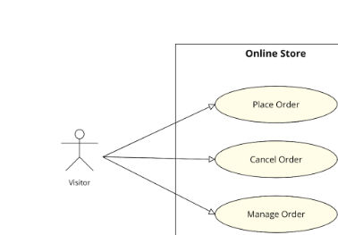
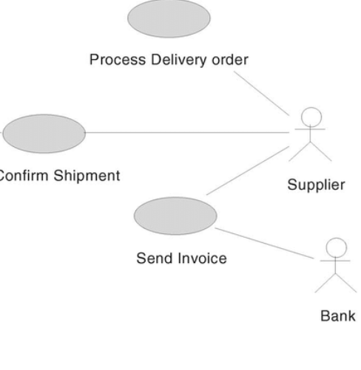

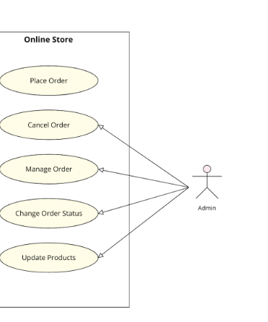

- System Architecture

FootwearRedux adopts a layered architecture that enhances maintainability, scalability, and efficiency:
Frontend Layer:
This layer leverages React and Next.js to create an engaging and responsive user interface. It handles user interactions, such as product browsing and cart management. Communication with the backend occurs through RESTful APIs, enabling seamless data exchange.
Backend Layer: Java Spring Boot forms the backbone of the backend. It manages core functionalities, including user authentication, product catalog management, order processing, and more. RESTful APIs exposed by the backend facilitate communication with the frontend, enabling data retrieval and transaction orchestration.
Database Layer: The PostgreSQL database securely stores and manages product details, user profiles, order histories, and other critical data. Its relational structure ensures data integrity and supports complex queries.
Key Benefits:
- Layered architecture promotes modular design, making it easier to maintain and update individual components.
- RESTful APIs enable decoupled communication between the frontend and backend, allowing for flexibility in development.
- Java Spring Boot ensures reliability and extensibility for business logic.
- PostgreSQL ensures data reliability, consistency, and scalability.
Scalability Considerations:
- The architecture is designed for horizontal scalability, accommodating a growing user base and product catalog.
- Techniques like caching and load balancing can enhance performance.
- Database scaling strategies, such as sharding or replication, can efficiently manage data growth.
- Design
8.1. General Architecture Diagram
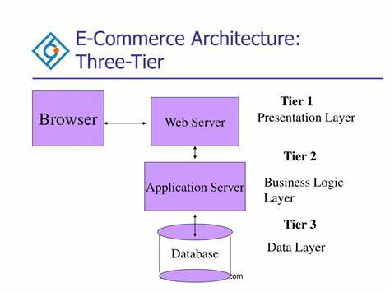
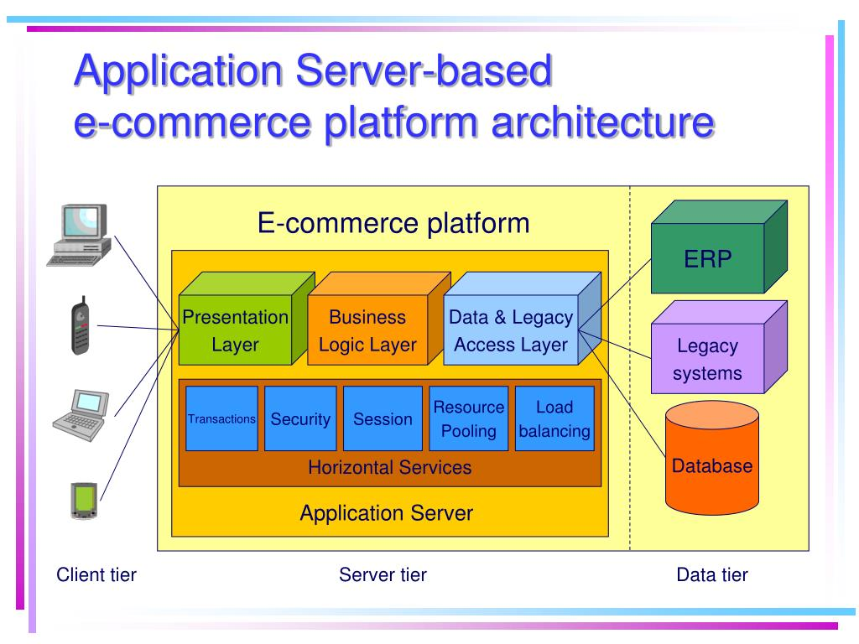
8.2. Object Diagram
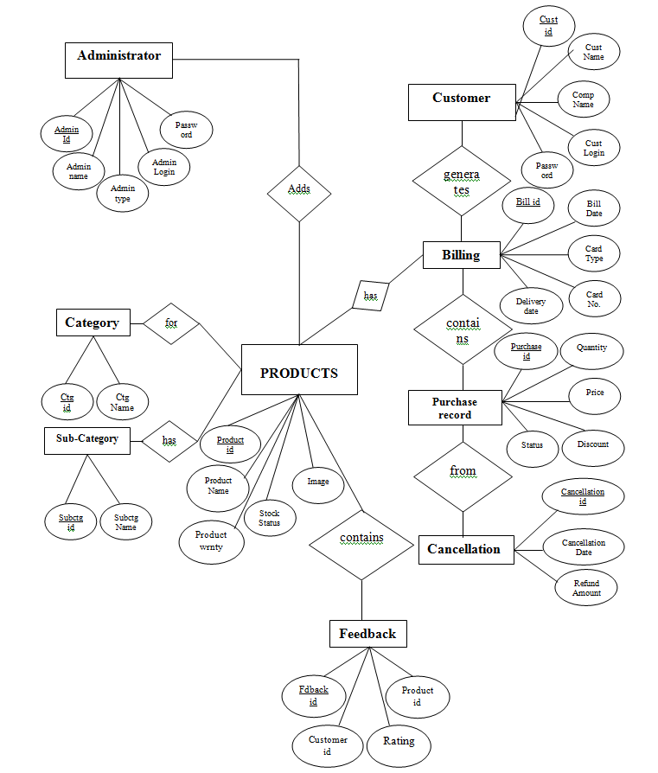

8.3. Class Diagram
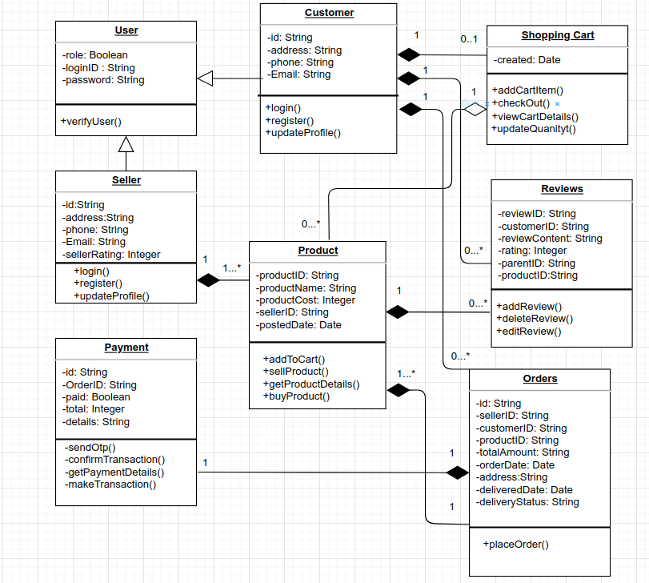

8.4. Activity Diagram
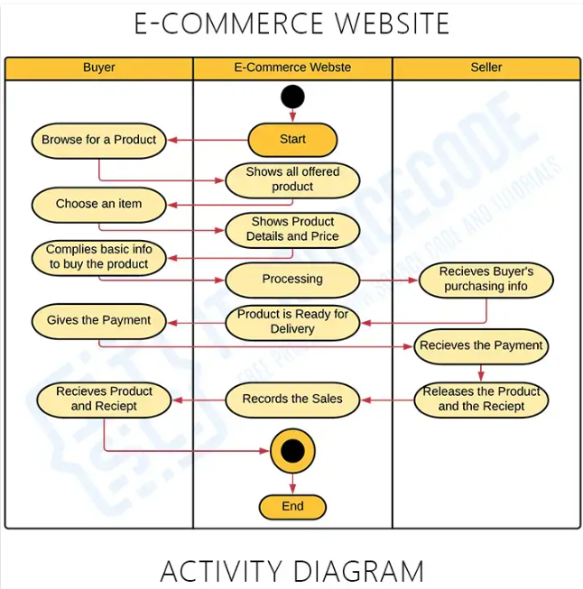

8.5. State Transition Diagram
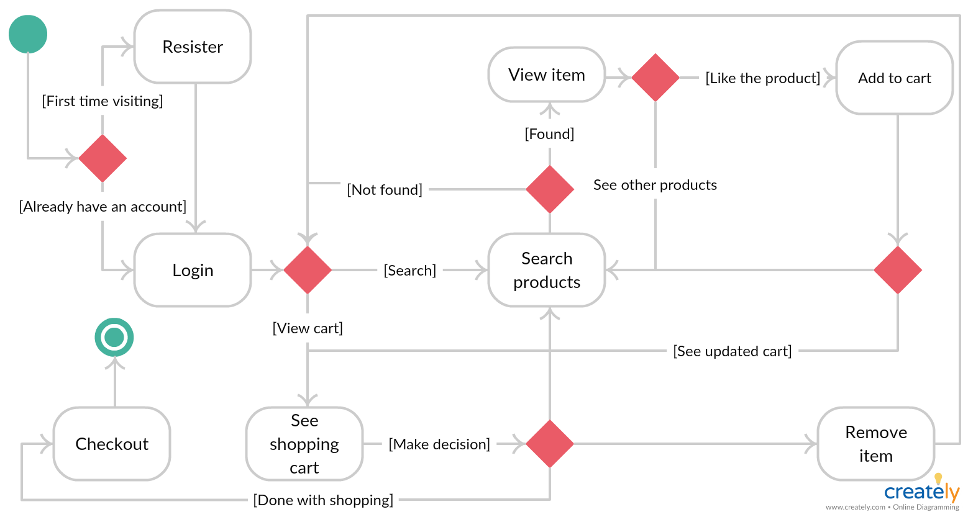
8.6. Component Diagram
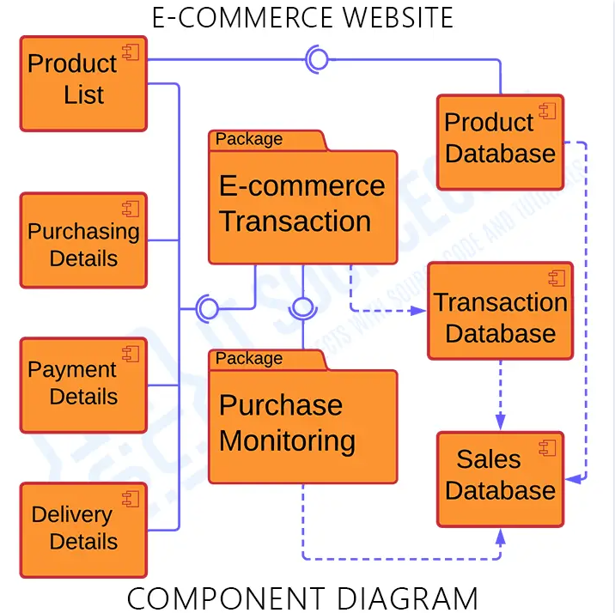

8.7. Package Diagram
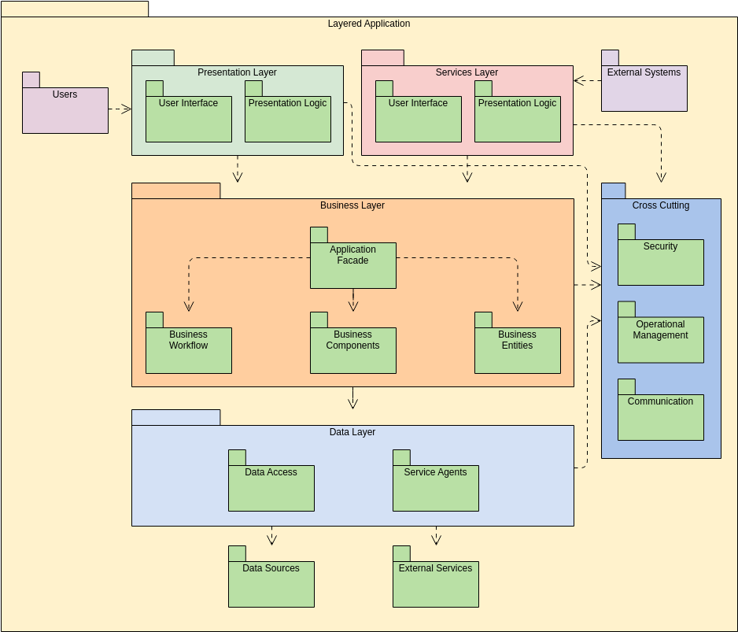

8.8. Deployment Diagram
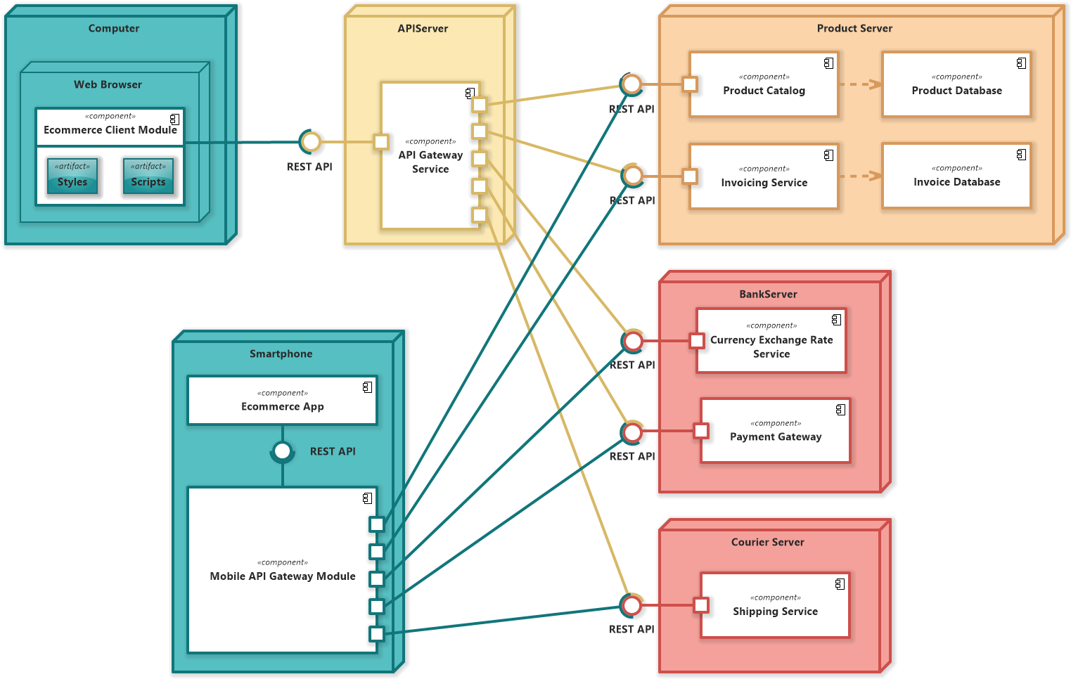

8.9. Interaction Diagram
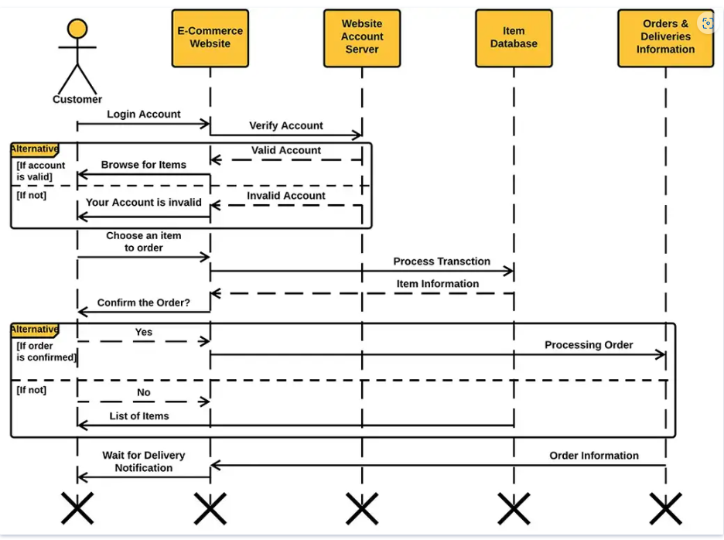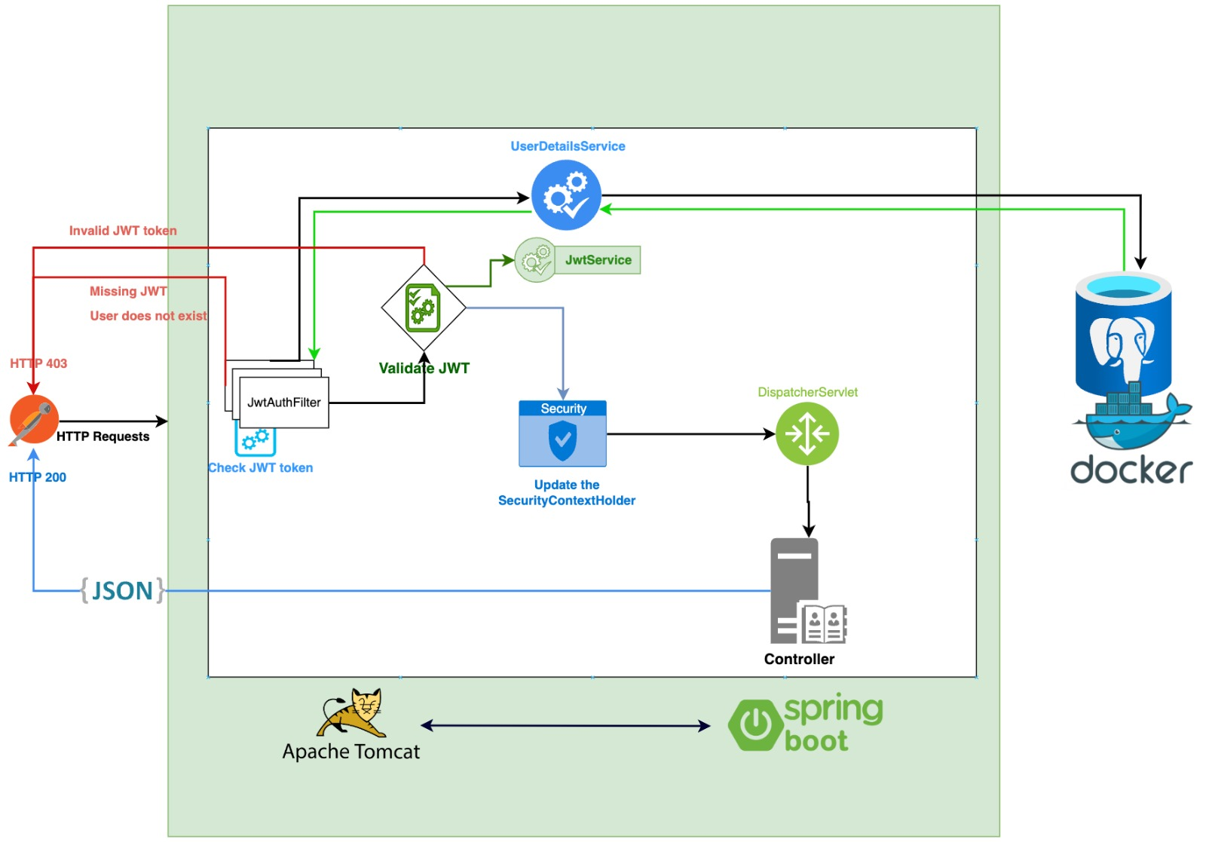
8.10. Database Structure
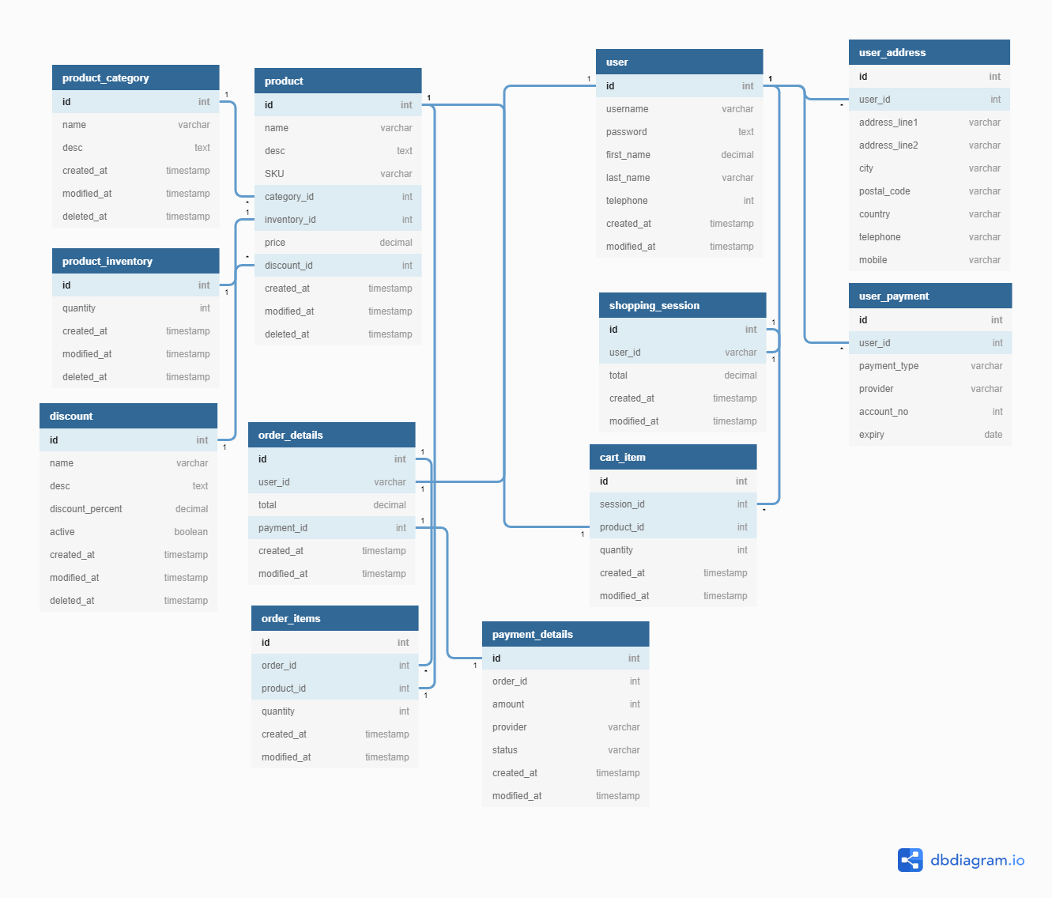

8.11.
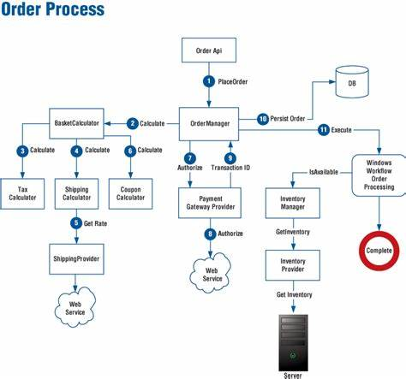
8.12.

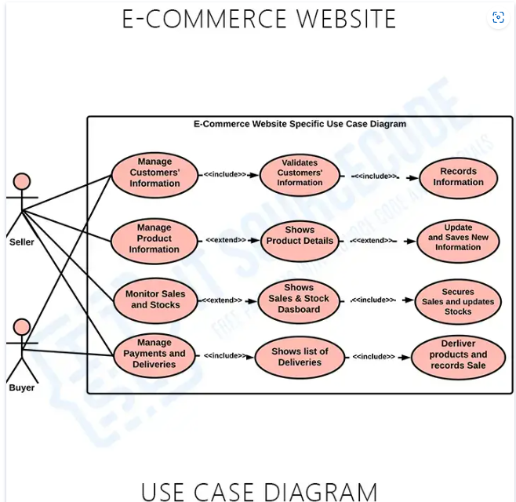
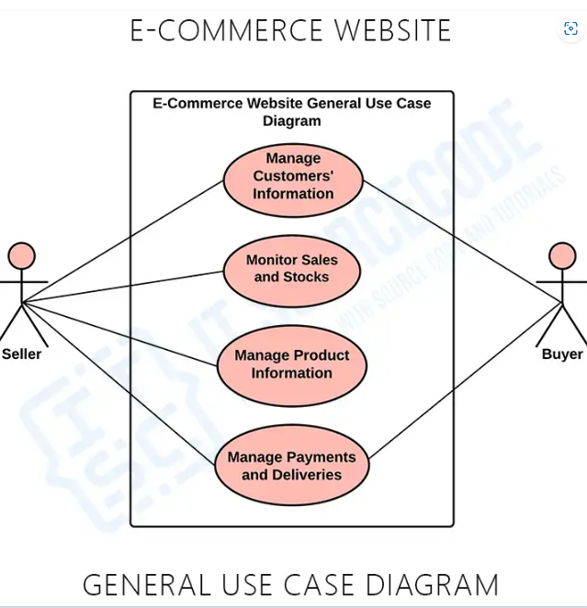

- Operation Mode (Interactivity presentation) + screen shots (UI design)

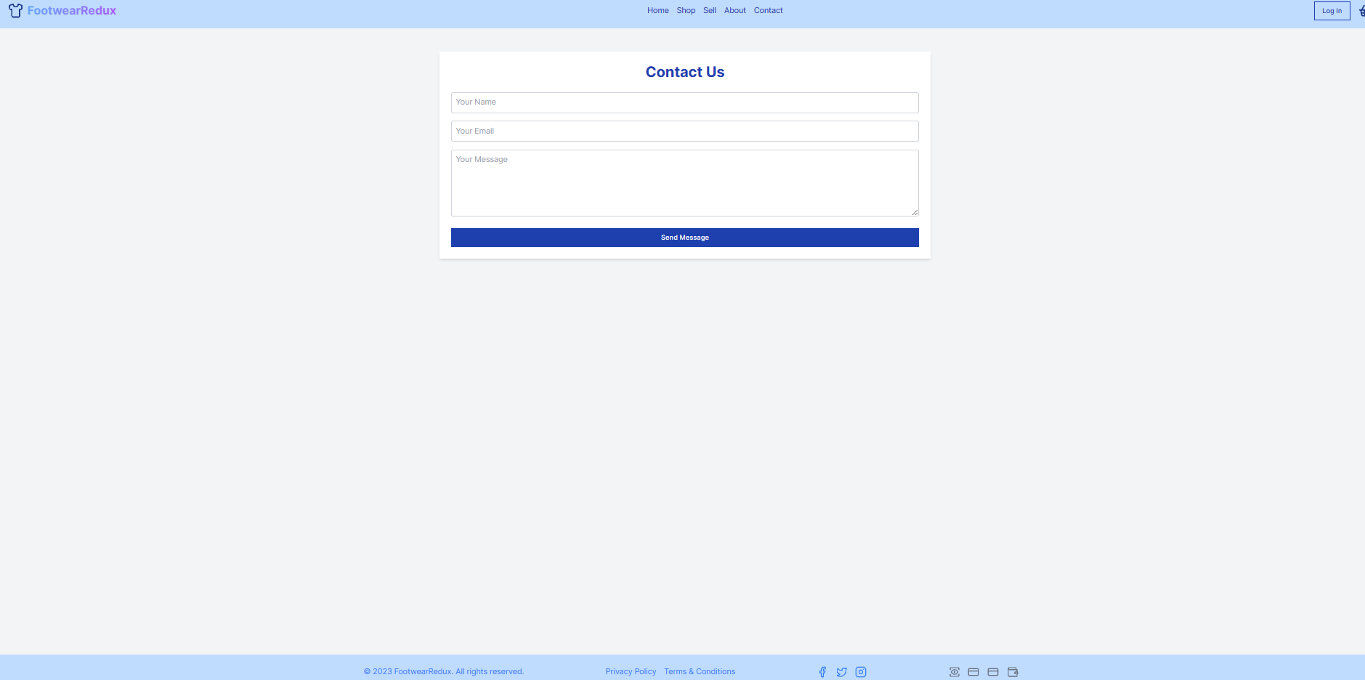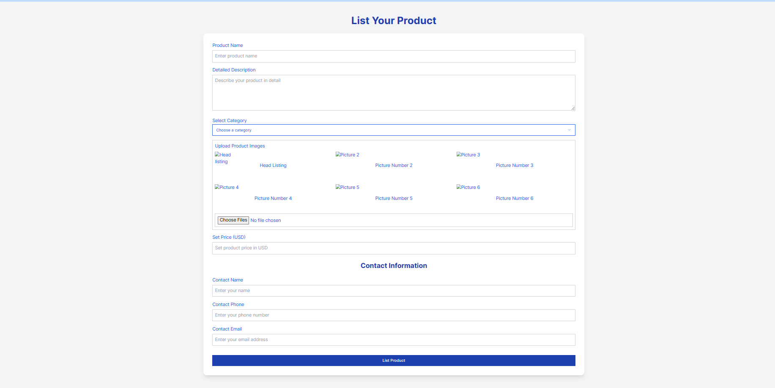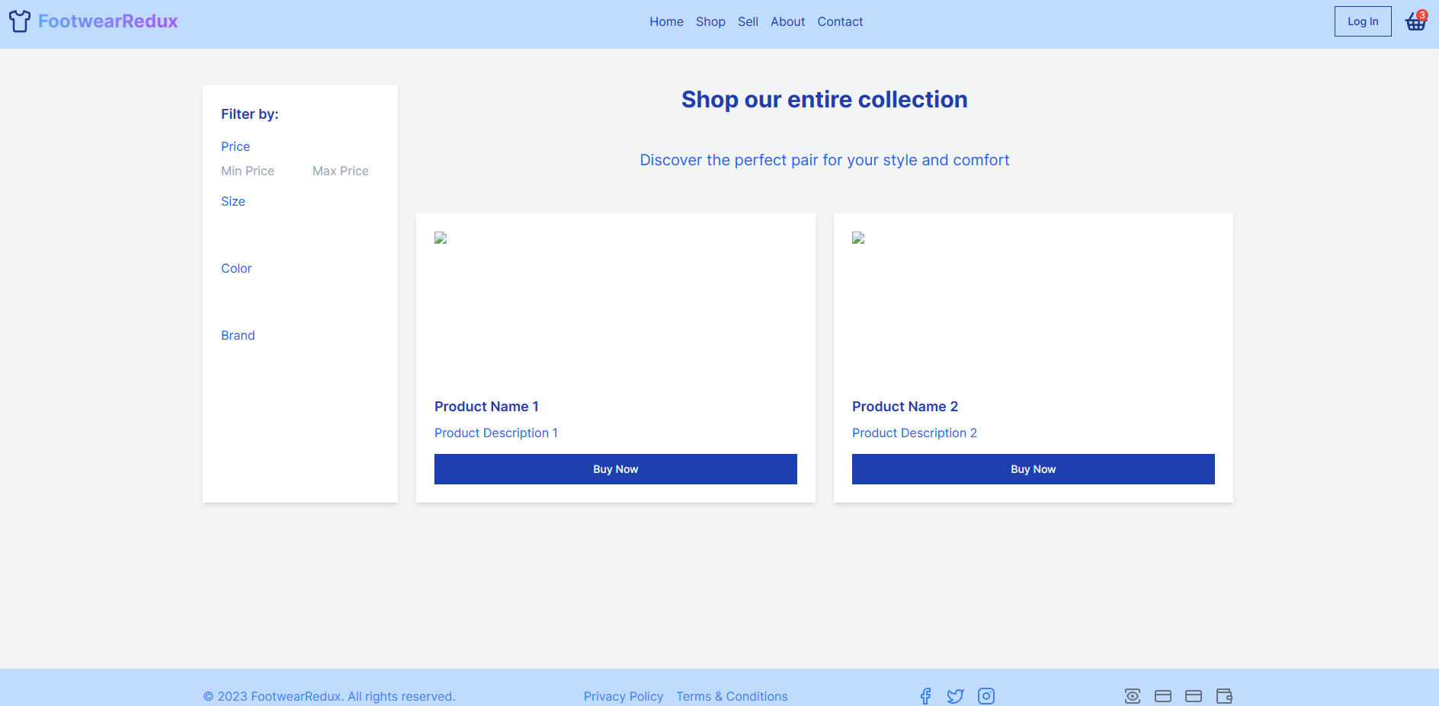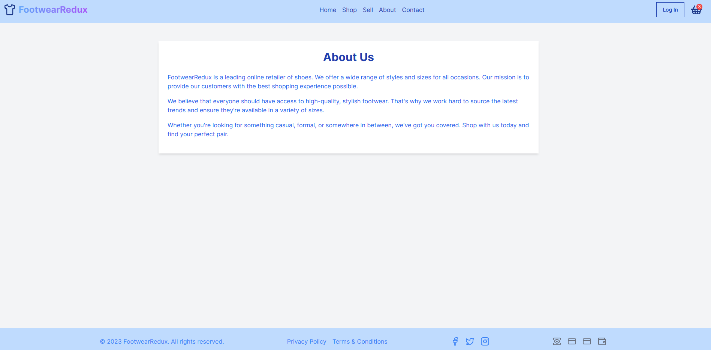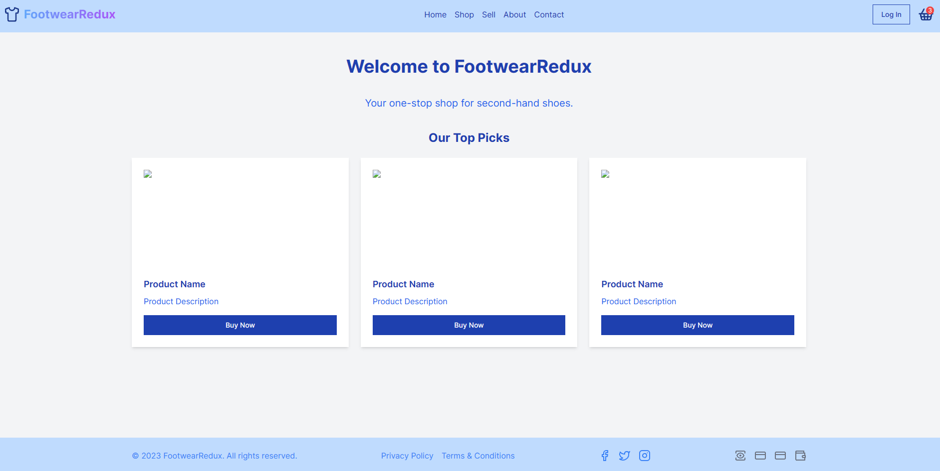

- Portability

The FootwearRedux project exhibits a high level of portability, allowing it to be easily deployed and run across various environments and platforms. This portability is achieved through the use of technologies like Java Spring Boot, React, and PostgreSQL, which are known for their cross-platform compatibility.

Java Spring Boot, being a Java-based framework, provides platform independence, allowing the project to run on different operating systems such as Windows, macOS, and Linux. This flexibility enables the deployment of FootwearRedux on a wide range of servers and cloud platforms, ensuring that the project can be easily scaled and hosted based on specific requirements.

React, as a JavaScript library, is designed to be platform-agnostic. It enables the creation of web applications that can run on different browsers and devices, including desktops, tablets, and mobile devices. This responsiveness ensures that FootwearRedux can provide a consistent and optimized user experience across various platforms.

In terms of data storage, PostgreSQL, being a widely used and supported database management system, can be deployed on multiple platforms, including Windows, macOS, and various Linux distributions. This flexibility allows FootwearRedux to seamlessly adapt to different deployment environments and integrate with existing infrastructure.

The combination of these technologies ensures that the FootwearRedux project can be easily moved and deployed across different platforms and environments. Whether it is on-premises servers, cloud-based infrastructure, or different operating systems, the project's portability provides the flexibility needed for efficient deployment and operation.
- Competing software

FootwearRedux competes with StockX, a world-leading pre-owned and new shoe platform. To differentiate itself, FootwearRedux focuses on sustainability and affordability, providing a dedicated marketplace for pre-owned shoes. It emphasizes a user-friendly experience, robust security measures, and aims to foster a sense of community among like-minded individuals. By capitalizing on these unique features, FootwearRedux aims to attract a dedicated user base in the competitive market.

